**Exp No:7**

7 .Practice Queries using ANY, ALL, IN, EXISTS, UNION, INTERSECT Set Operators

Set operators combine the results of two queries into a single one. The following set operators are availablein SQL.

* Union
* Union All
* Interset
* Minus

1.ANY

*SELECT ProductName*

*FROM Products*

*WHERE ProductID = ANY (SELECT ProductID FROM OrderDetails WHERE Quantity = 1);*

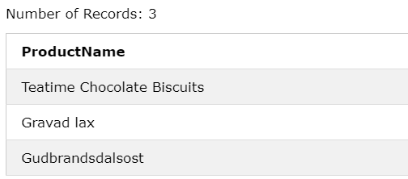

*SELECT ProductName*

*FROM Products*

*WHERE ProductID = ANY (SELECT ProductID FROM OrderDetails WHERE Quantity > 1000);*

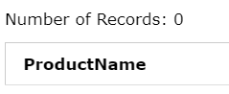

2.ALL

*SELECT ALL ProductName*

*FROM Products*

*WHERE TRUE;*

*​*



*SELECT ProductName  
FROM Products  
WHERE ProductID = ALL  
  (SELECT ProductID  
  FROM OrderDetails  
  WHERE Quantity = 10);*

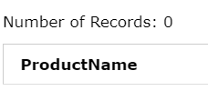

3.IN

*SELECT * FROM Customers*

*WHERE Country IN (SELECT Country FROM Suppliers);*

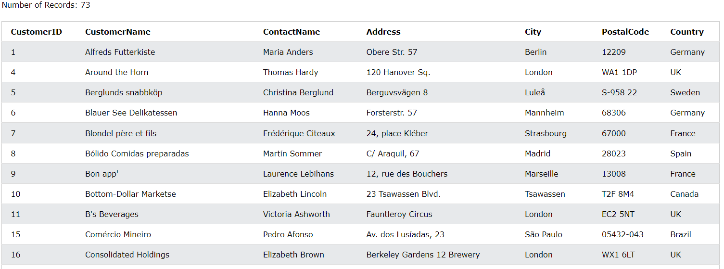

4.*.*EXISTS

*SELECT SupplierName*

*FROM Suppliers*

*WHERE EXISTS (SELECT ProductName FROM Products WHERE Products.SupplierID = Suppliers.supplierID AND Price = 22);*

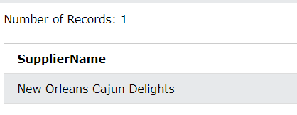

*5.*UNION

*SELECT City, Country FROM Customers*

*WHERE Country='Germany'*

*UNION ALL*

*SELECT City, Country FROM Suppliers*

*WHERE Country='Germany'*

*ORDER BY City;*

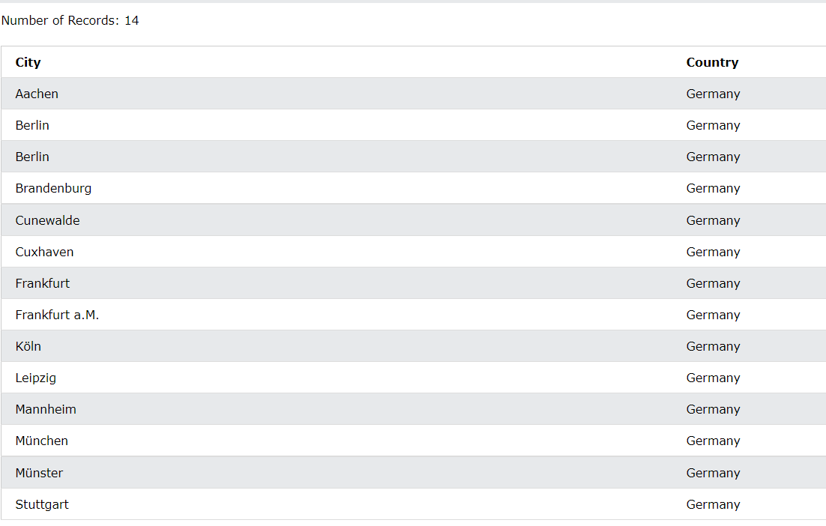

6.INTERSECT

*SELECT City FROM Customers*

*UNION ALL*

*SELECT City FROM Suppliers*

*ORDER BY City;*

